This is the second part of *Analyzing the Greatest Strikers in Football*. In the [first part](http://blog.schochastics.net/post/analyzing-the-greatest-strikers-in-football-i-getting-data/),  
we created the function get_goals() which allows us to conveniently scrape detailed information of players  
career goals from [transfermarkt.co.uk](https://www.transfermarkt.co.uk/). In this part,  
we are going to explore the data.

library(tidyverse) # for data wrangling

library(lubridate) # for date formats

library(ggimage) # adding images to ggplot

library(patchwork) # attaching ggplot objects

library(viridis) # viridis color schemes

We start by getting the data of Zlatan with the get_goals() function.

zlatan_tbl <- get_goals(player = "zlatan-ibrahimovic", id = "3455")

glimpse(zlatan_tbl)

## List of 4

## $ data :'data.frame': 423 obs. of 13 variables:

## ..$ competition: chr [1:423] "Eredivisie" "Eredivisie" "UEFA Cup" "UEFA Cup" ...

## ..$ day : chr [1:423] "3" "4" "First Round" "First Round" ...

## ..$ date : Date[1:423], format: "2001-08-26" ...

## ..$ venue : chr [1:423] "A" "A" "H" "A" ...

## ..$ against : chr [1:423] "Feyenoord  " "FC Twente  " "Apol. Limassol" "Apol. Limassol" ...

## ..$ minute : num [1:423] 64 19 4 64 68 79 68 78 95 47 ...

## ..$ standing : chr [1:423] "0:1" "0:1" "1:0" "0:2" ...

## ..$ type : chr [1:423] "Tap-in" "" "" "Header" ...

## ..$ provider : chr [1:423] "Hatem Trabelsi" "" "Nikolaos Machlas" "Wamberto" ...

## ..$ club : Factor w/ 8 levels "Ajax Amsterdam",..: 1 1 1 1 1 1 1 1 1 1 ...

## ..$ club_crest : chr [1:423] "https://tmssl.akamaized.net//images/wappen/head/610.png" "https://tmssl.akamaized.net//images/wappen/head/610.png" "https://tmssl.akamaized.net//images/wappen/head/610.png" "https://tmssl.akamaized.net//images/wappen/head/610.png" ...

## ..$ age : num [1:423] 19.9 19.9 20 20 20.2 ...

## ..$ goals : int [1:423] 1 2 3 4 5 6 7 8 9 10 ...

## $ name : chr "Zlatan Ibrahimovic"

## $ birthday: Date[1:1], format: "1981-10-03"

## $ portrait: chr "https://tmssl.akamaized.net//images/portrait/header/3455-1521831775.jpg?lm=1521831871"

For comparisons, we also grab the data for Messi and CR7.

messi_tbl <- get_goals("lionel-messi","28003")

cr7_tbl <- get_goals("cristiano-ronaldo","8198")

**Greating a ggplot theme**

This is a totally optional step, but I like to use a customized ggplot theme to make the  
plots more unique.

theme_goals <- function(base_family="Roboto Condensed",

ticks=TRUE,axis=TRUE,grid=""){

ret <- theme_bw()+

theme(panel.background = element_rect(fill="#666666",colour = "#666666"),

plot.background = element_rect(fill="#666666",colour = "#666666"),

panel.grid.minor = element_blank(),

panel.border = element_rect(fill=NA,colour="#666666"),

legend.background = element_rect(fill="#666666",colour = "#666666"),

legend.box.background = element_rect(fill="#666666",colour = "#666666"),

legend.key = element_rect(fill="#666666",colour = "#666666"),

legend.text = element_text(family = base_family,colour="white",size=rel(1.1)),

axis.text = element_text(colour="white",size=rel(0.9),family=base_family),

axis.title = element_text(family = base_family,colour="white",size=rel(1.1)),

legend.position = "bottom",

plot.title = element_text(family = base_family,color="white",face = "bold",size=rel(1.5)),

plot.subtitle = element_text(family = base_family,color="white"))

if(ticks){

ret <- ret + theme(axis.ticks = element_line(colour="white"))

} else {

ret <- ret + theme(axis.ticks = element_blank())

}

if(axis){

ret <- ret + theme(axis.line = element_line(colour="white"))

} else {

ret <- ret + theme(axis.line = element_blank())

}

if(grid==""){

ret <- ret + theme(panel.grid = element_blank())

} else if(grid=="y"){

ret <- ret + theme(panel.grid.major.x = element_blank(),

panel.grid.major.y = element_line(colour="white",size=0.1))

} else if(grid=="x"){

ret <- ret + theme(panel.grid.major.y = element_blank(),

panel.grid.major.x = element_line(colour="white",size=0.1))

}

ret

}

Let’s move on to the more interesting part.

**Goals over time and per club**

# calculate position of crests

crest_pos <- zlatan_tbl$data %>%

group_by(club) %>%

summarise(x = mean(age),

y = mean(goals),

crest = club_crest[1])

ggplot(zlatan_tbl$data,aes(x=age,y=goals,col=club))+

geom_image(data=crest_pos,aes(x=x,y=y,image=crest),size=0.05,alpha=0.5)+

geom_line()+

scale_color_viridis_d(option = "viridis", name = "")+

theme_goals(grid = "y")+

labs(title=zlatan_tbl$name,

subtitle=paste(nrow(zlatan_tbl$data),"goals between",

min(zlatan_tbl$data$date),"and",max(zlatan_tbl$data$date))) -> p_date

p_date

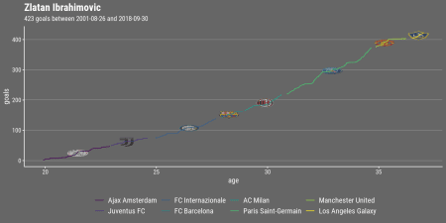

Zlatan truly is a prolific player, having scored more than 400 goals for 8 different clubs.  
But his achievements in terms of goals scored fade compared to Messi and CR7.

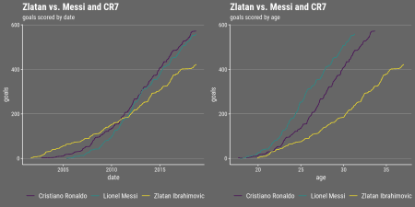

**Goals per minute and standing**

Below we look at the number of goals scored per ingame minute, excluding extra time.

zlatan_tbl$data$y <- floor(zlatan_tbl$data$minute/10)

zlatan_tbl$data$x <- zlatan_tbl$data$minute%%10

zlatan_tbl$data$y[zlatan_tbl$data$x==0] <- zlatan_tbl$data$y[zlatan_tbl$data$x==0]-1

zlatan_tbl$data$x[zlatan_tbl$data$x==0] <- 10

zlatan_tbl$data %>%

dplyr::filter(minute<=90) %>%

group_by(x,y,minute) %>%

count() %>%

ggplot(aes(x,y))+geom_tile(aes(fill=n),colour="#666666",size=1)+

geom_text(aes(label=n))+

scale_y_reverse(breaks=0:8,

labels=c("1'-10'","11'-20'","21'-30'","31'-40'","41'-50'","51'-60'",

"61'-70'","71'-80'","81'-90'"))+

viridis::scale_fill_viridis(option = "D",name="",limits=c(0,15),na.value="#FF7F00")+

theme_goals(ticks = F,axis = F,grid = "")+

theme(axis.text.x = element_blank(),

legend.position = "none")+

coord_fixed()+

labs(x="",y="",subtitle="Goals scored per ingame minute") -> p_min

p_min

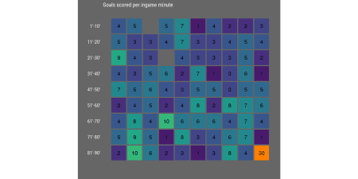

The only ingame minute he has not scored yet is the 3rd and the 24th[1](http://blog.schochastics.net/post/analyzing-the-greatest-strikers-in-football-ii-visualizing-data/#fn1). Let’s see how he compares with Messi an CR7 in that matter.

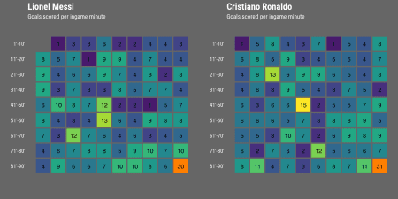

Messi seems to still miss a goal in the first minute. CR7 on the other hand managed to  
score in every single minute of a game. He is, however, not alone in this exclusive club.  
I found three more strikers (Alessandro Del Piero, Gerd Müller and Raúl) who, according to  
transfermarkt.co.uk, also scored in every minute of the game. The figure below shows their  
break downs per minute, together with five more strikers who come close to scoring in each minute.

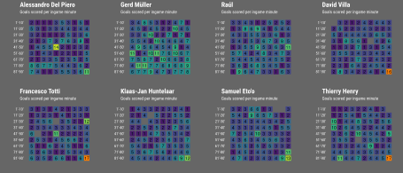

*I have to shamefully admit that I forgot to check Luis Suárez and Sergio Agüero in my initial analysis. Lo and behold,  
both have scored in 89 minutes!*

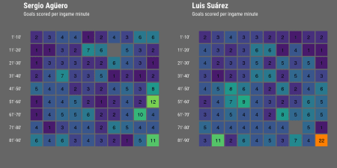

Next, we will look at the standing of the match a goal was scored. Note that we have  
to adjust the standing for away games since it is given in the “wrong” order. That is,  
we need to treat 0:1 as 1:0. This can be done by reversing the string with stringi::stri_reverse().  
Be careful though! This only works for single digit standings.

stringi::stri_reverse("1:10")

## [1] "01:1"

zlatan_tbl$data %>%

mutate(standing_adj = ifelse(venue=="A",stringi::stri_reverse(standing),standing)) %>%

group_by(standing_adj) %>%

summarise(goals = n()) %>%

ggplot(aes(x = reorder(standing_adj,-goals),y = goals))+

geom_col(fill="#FF7F00")+

theme_goals(grid = "y")+

labs(x = "standing after goal", y = "count") -> p_stand

p_stand

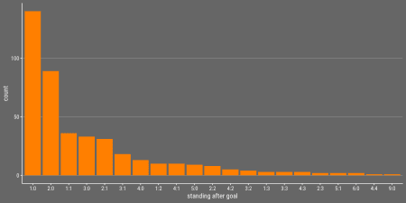

**Type of Goal and the Providers**

The columns we haven’t looked at yet are the type and provider.

zlatan_tbl$data %>%

dplyr::filter(provider!="") %>%

group_by(provider) %>%

summarise(goals = n()) %>%

top_n(10,goals) %>%

ggplot(aes(x = reorder(provider,goals),y = goals))+

geom_col(fill="#FF7F00")+

scale_y_continuous(breaks=seq(0,12,3))+

theme_goals(grid = "x")+

labs(x = "", y = "count",subtitle="Top ten providers")+

coord_flip() -> p_prov

zlatan_tbl$data %>%

dplyr::filter(type!="") %>%

group_by(type) %>%

summarise(goals = n()) %>%

ggplot(aes(x = reorder(type,goals),y = goals))+

geom_col(fill="#FF7F00")+

theme_goals(grid = "x")+

labs(x = "", y = "count",subtitle="Type of goal")+

coord_flip() -> p_type

p_prov +

p_type +

plot_layout(nrow = 1) +

plot_annotation(theme=theme(

plot.background=element_rect(fill="#666666",colour="#666666"),

plot.title = element_text(family = "Roboto Condensed",color="white",face = "bold",size=rel(1.5))),

title=zlatan_tbl$name)

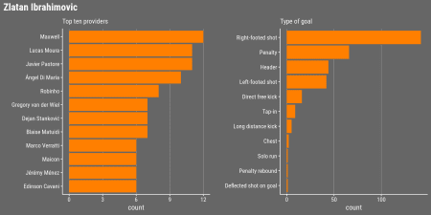

According to his transfermarkt [profile](https://www.transfermarkt.co.uk/zlatan-ibrahimovic/profil/spieler/3455),  
Zlatan is “both-footed”, but he seems to prefer the right foot for scoring.

For comparison, here are the plots for Messi and CR7.  
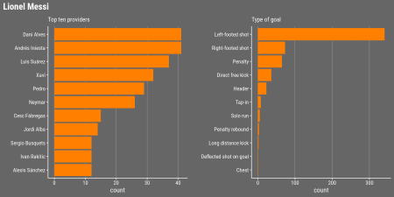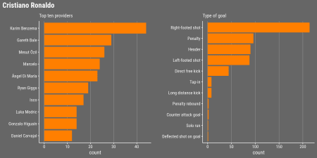

**Scorecard**

You can neatly put all plots together to create an informative scorecard for Zlatan.

p <- {p_date + p_stand + plot_layout(ncol = 2)}+

{p_min + p_prov + p_type + plot_layout(ncol = 3)}+

plot_layout(ncol = 1) +

plot_annotation(theme = theme(

plot.background = element_rect(fill="#666666",colour="#666666")))

p

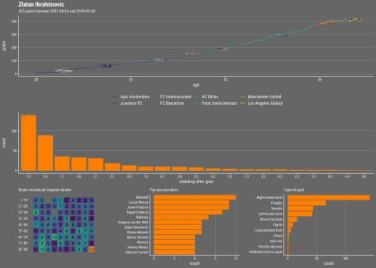

The code for the plots is kept as general as possible, so that it is easy to produce them  
quickly for any other player found on transfermarkt. Below are two more scorecards that  
were created in the same way as for Zlatan.

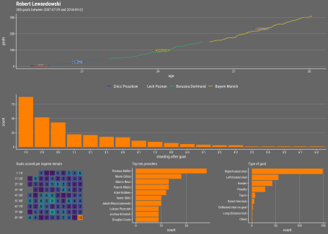

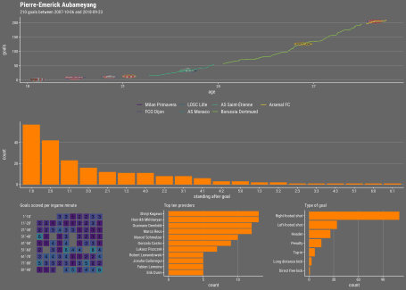

1. according to [this](https://www.reddit.com/r/soccer/comments/6rug3f/players_who_have_scored_in_every_minute_of_a/) reddit post, Zlatan has in fact scored in every minute if one includes national team matches.[](http://blog.schochastics.net/post/analyzing-the-greatest-strikers-in-football-ii-visualizing-data/#fnref1)